2026 3 8

model structure
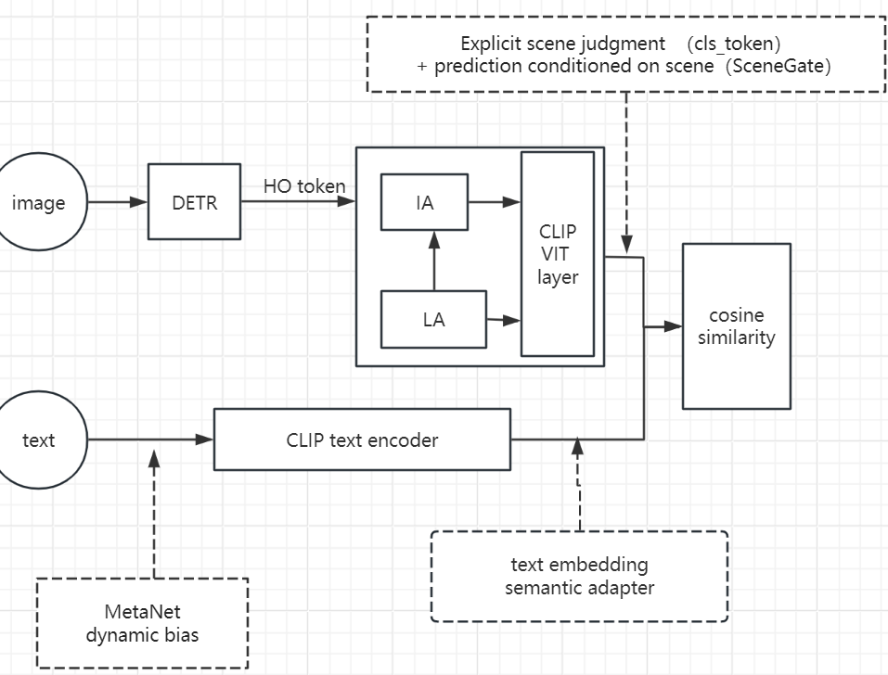

This document describes the adapter component.

2 Zero-Shot Bias Analysis
We conduct a preliminary analysis on the HICO-det dataset under the rare first zero-shot setting ^{[4]}. The model is trained only on seen classes, and we evaluate the score distributions for seen vs. unseen classes.
Observation 1 Over-confidence on a few “confusing” seen classes: Certain seen classes that share visual or semantic similarity with many unseen classes are repeatedly predicted with high confidence. For instance, the class “eat” (index 162) and “hold” (index 277) appear as false positives for a large number of unseen interactions.
Observation 2 Score imbalance: The average logit for seen classes is higher than that for unseen classes. Even when an unseen interaction is correctly represented, its score is often suppressed by competing seen classes.
These observations motivate a post-processing strategy that does not alter the learned representations but merely re‑calibrates the output scores.

3 Lightweight Semantic Adapter
To bridge the gap between general-purpose CLIP embeddings and task-specific HOI categories, we introduce a Parameter-Efficient Semantic Adapter with Low-Rank Adaptation (LoRA), which refines the output features from the frozen CLIP text encoder. This module captures nuanced semantic relationships between human actions and objects in HOI detection without fine-tuning the massive CLIP backbone parameters, while further reducing the number of trainable parameters via low-rank decomposition.
3.1 Architecture Design
The Semantic Adapter follows a bottleneck architecture with a residual connection and integrates a LoRA layer to enhance parameter efficiency. For a given input text embedding generated by the frozen CLIP text encoder (where $d$ denotes the dimension of CLIP text features, set to 512 in our implementation), the adapted feature $t^{'}$ is computed as:
$$t'=t+W_{up}⋅GELU(LoRA(W_{down}⋅LN(t)))$$
where:
- $LN(⋅)$ denotes the Layer Normalization applied to the input features to stabilize the optimization process.
- and are the weight matrices of two linear projection layers without bias terms, where r is the bottleneck dimension (set to 64 in our implementation).
- $GELU(⋅)$ Gaussian Error Linear Unit activation function, which provides smoother non-linearity compared to ReLU and better fits the Transformer-based CLIP text encoder;
- $LoRA(⋅)$ A low-rank adaptation layer that decomposes the full-rank transformation in the bottleneck space into two small matrices A∈Rk×r and B∈Rr×k (where k is the rank, set to 4 in our implementation). The LoRA transformation is scaled by α/k (with α=16) to balance the output magnitude:
$$LoRA(⋅)=\frac{α}{k}⋅B⋅A⋅x$$
- 0.1: A residual scaling factor to control the contribution of the adapter branch and preserve the original CLIP semantic space;
- Residual connection: The original CLIP text embedding $t$is retained to ensure the adapter only learns task-specific offsets without disrupting the pre-trained semantic knowledge

3.2 Zero-initialized Residual Learning
A key feature of our adapter is the initialization strategy of the up-projection layer. Specifically, we initialize with zeros:
This initialization ensures that at the beginning of the training phase, the output of the adapter branch is zero, meaning . This property preserves the high-quality zero-shot capabilities of the pretrained CLIP model, allowing the adapter to progressively learn task-specific offsets without disrupting the original semantic space.
Text Prompts
→ CLIP Text Encoder → [N, 512]
→ Normalization
→ Text Semantic Adapter → [N, 512]
→ Dynamic Projection → [N, D]
→ Normalization
→ Similarity Computation

4.Result
NF task
model | mAP（%） | unseen mAP（%） | seen mAP（%） | rare mAP（%） | Non rare mAP（%）
Complex(30epoch) | 30.44 | 34.02 | 29.54 | 28.95 | 30.88
Simple(30epoch) | 32.29 | 35.66 | 31.44 | 33.25 | 32.00
Lora(20 epoch) | 32.41 | 36.37 | 31.42 | 32.80 | 31.80
LAIN(base) | 33.23 | 36.41 | 32.11 | 35.75 | 32.75
Initially, we designed a complex adapter by incorporating multi-gate control into the text semantic adapter. However, after training, we found that this complex multi-gate structure did not yield performance improvements and was outperformed by the simpler baseline adapter, which only applied basic linear transformations.
Subsequently, we adjusted our strategy: based on the better-performing simple adapter, we introduced LoRA (Low-Rank Adaptation) for lightweight fine-tuning. This allowed us to adapt the text features using low-rank matrices, maintaining the lightweight nature of the adapter while better capturing fine-grained variations in text semantics.
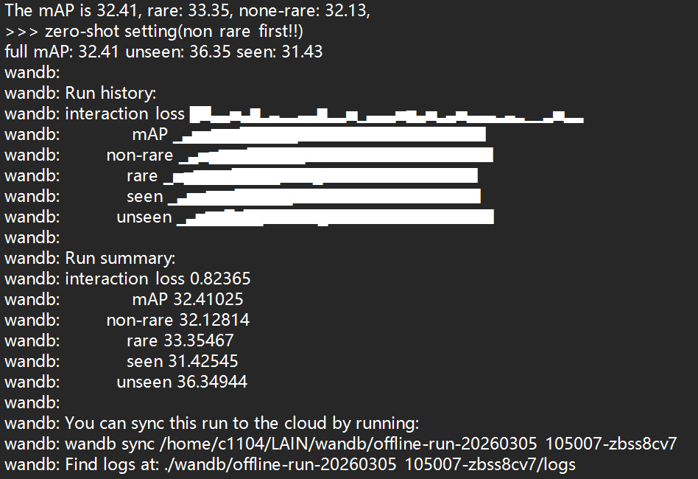
Figure 1 Result for Lora-adapter
We will next test additional hyperparameters and validate the training performance of the visually-added scene module.
The combining model has not yet undergone experimental evaluation.

5 Suppression-Boost Post-Processing Strategy（This part has not been tested yet.）
To mitigate the inherent seen-class bias observed in zero-shot HOI detection, we propose a lightweight, post-hoc calibration mechanism termed the Suppression-Boost (SB) strategy. Unlike methods that require expensive re-training, our SB strategy re-calibrates the model's confidence scores during inference through class-specific multiplicative rescaling.
5.1 Problem Observation
Through empirical analysis of the baseline model's predictions, we identify a systematic "over-claiming" issue: the model frequently assigns high confidence scores to seen interaction classes (e.g., hold, eat) even when the true interaction belongs to an unseen category. This bias stems from the unbalanced distribution of the training data, where seen classes dominate the embedding space.
5.2 Multiplicative Score Calibration
We calibrate the final HOI scores by applying a rescaling factor based on the class category (Seen vs. Unseen) and specific confusion patterns. Let denote the initial probability score for the -th HOI class, where is the sigmoid function. The calibrated score is computed as follows:
Where:
represents the set of "confusing" seen classes that exhibit high false-positive rates. Based on our error analysis, we identify key indices and assign specific suppression factors. For instance, we set and to significantly suppress high-frequency errors, while other identified indices {168, 276, 380, 598} are assigned a factor of 0.2.
denotes the set of zero-shot HOI classes. To encourage the model to prioritize these interactions, we apply a global boost factor .
This recalibration effectively reshapes the decision boundaries without altering the underlying feature representations. By selectively suppressing over-confident seen classes and marginally boosting unseen ones, the SB strategy significantly enhances the model's sensitivity to novel HOI categories while maintaining robust performance on seen data.

[1] Chao, Y.-W., Wang, Z., He, Y., Wang, J., & Deng, J. (2015). HICO: A Benchmark for Recognizing Human-Object Interactions in Images. International Conference on Computer Vision, 1017–1025. https://doi.org/10.1109/ICCV.2015.122
[2] Carion, Nicolas, et al. “End-to-End Object Detection with Transformers.” European Conference on Computer Vision, Springer, Cham, 2020, pp. 213–29, doi:10.1007/978-3-030-58452-8_13.
[3] Sutskever, Ilya, et al. “Learning Transferable Visual Models From Natural Language Supervision.” ArXiv: Computer Vision and Pattern Recognition, Feb. 2021.
[4] Mu, Tingting, and Alessio Sarullo. “Zero-Shot Human-Object Interaction Recognition via Affordance Graphs.” ArXiv: Computer Vision and Pattern Recognition, Sept. 2020.

